Micro-credential Guidelines for Student

Distance and remote locations are no barriers to your learning journey.
IMU e-training Learning Management System (LMS) acts as the main platform where you can access your learning materials at anytime and anywhere.

How to Log in to Your MiC Course Page

Your micro-credential course can be accessed via https://e-training.imu.edu.my/
Let's learn the step.

Steps | Description
STEP 1:  Go to https:/ e-training.imu.edu.my/ | 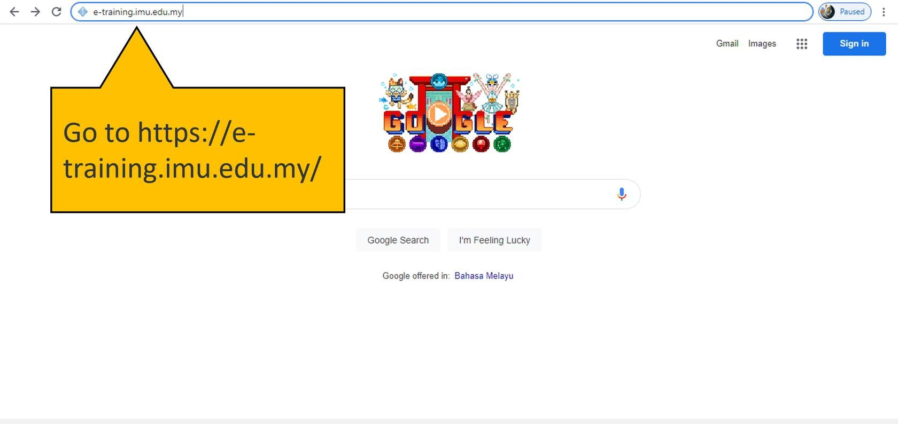
STEP 2:  Click Login/Register to log in to your course. | 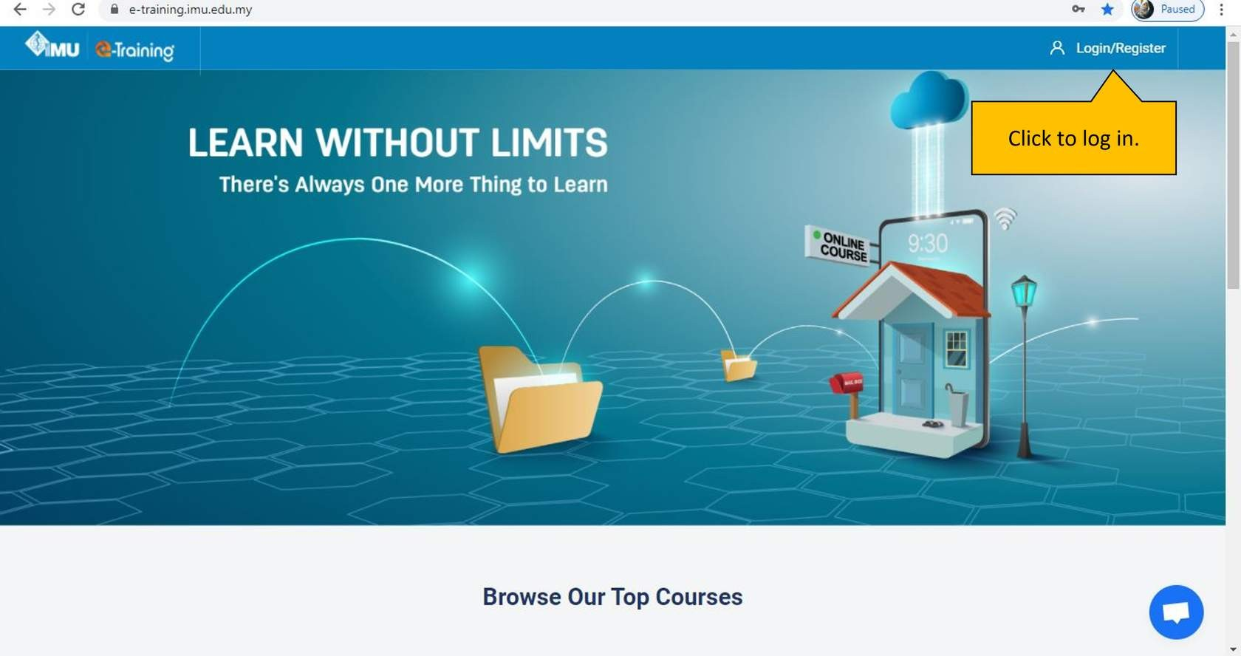
STEP 3:  Insert your username and password. | 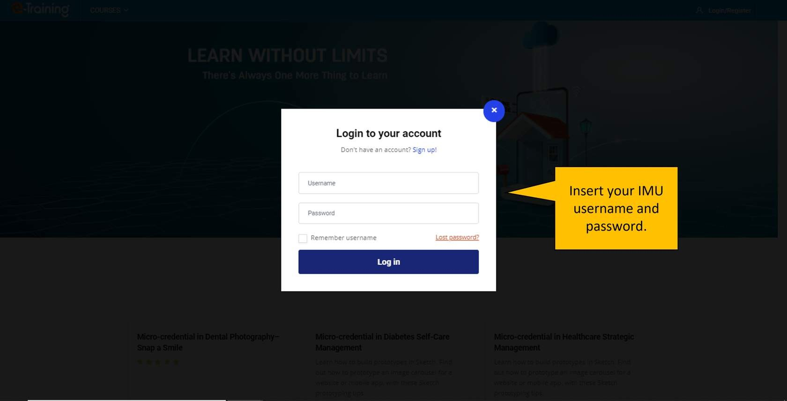  Insert your username and password.

Getting to Know The Dashboard

You will land on the Dashboard page when you first log into the portal.
The dashboard is an intuitive way of providing you with details of your course list, system announcements, and links to resource blocks.

Navigation
By clicking this gear icon,
you can see the link to your
dashboard and available
courses.

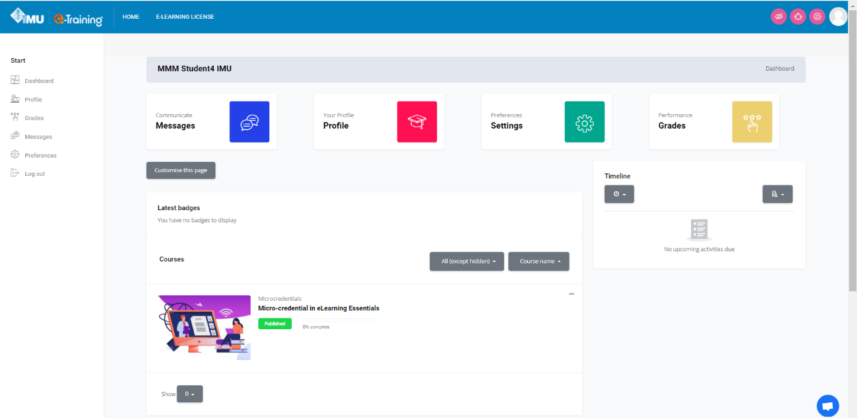
Courses
All enrolled courses will be listed here. Hover the grid image and click the “View” button to go the course.
Badges
All your e-badges will be displayed here.

Getting to Know The Site Home

Site Home page is the front page of e-Training portal.

Let's look at the front page of IMU e-Training portal.

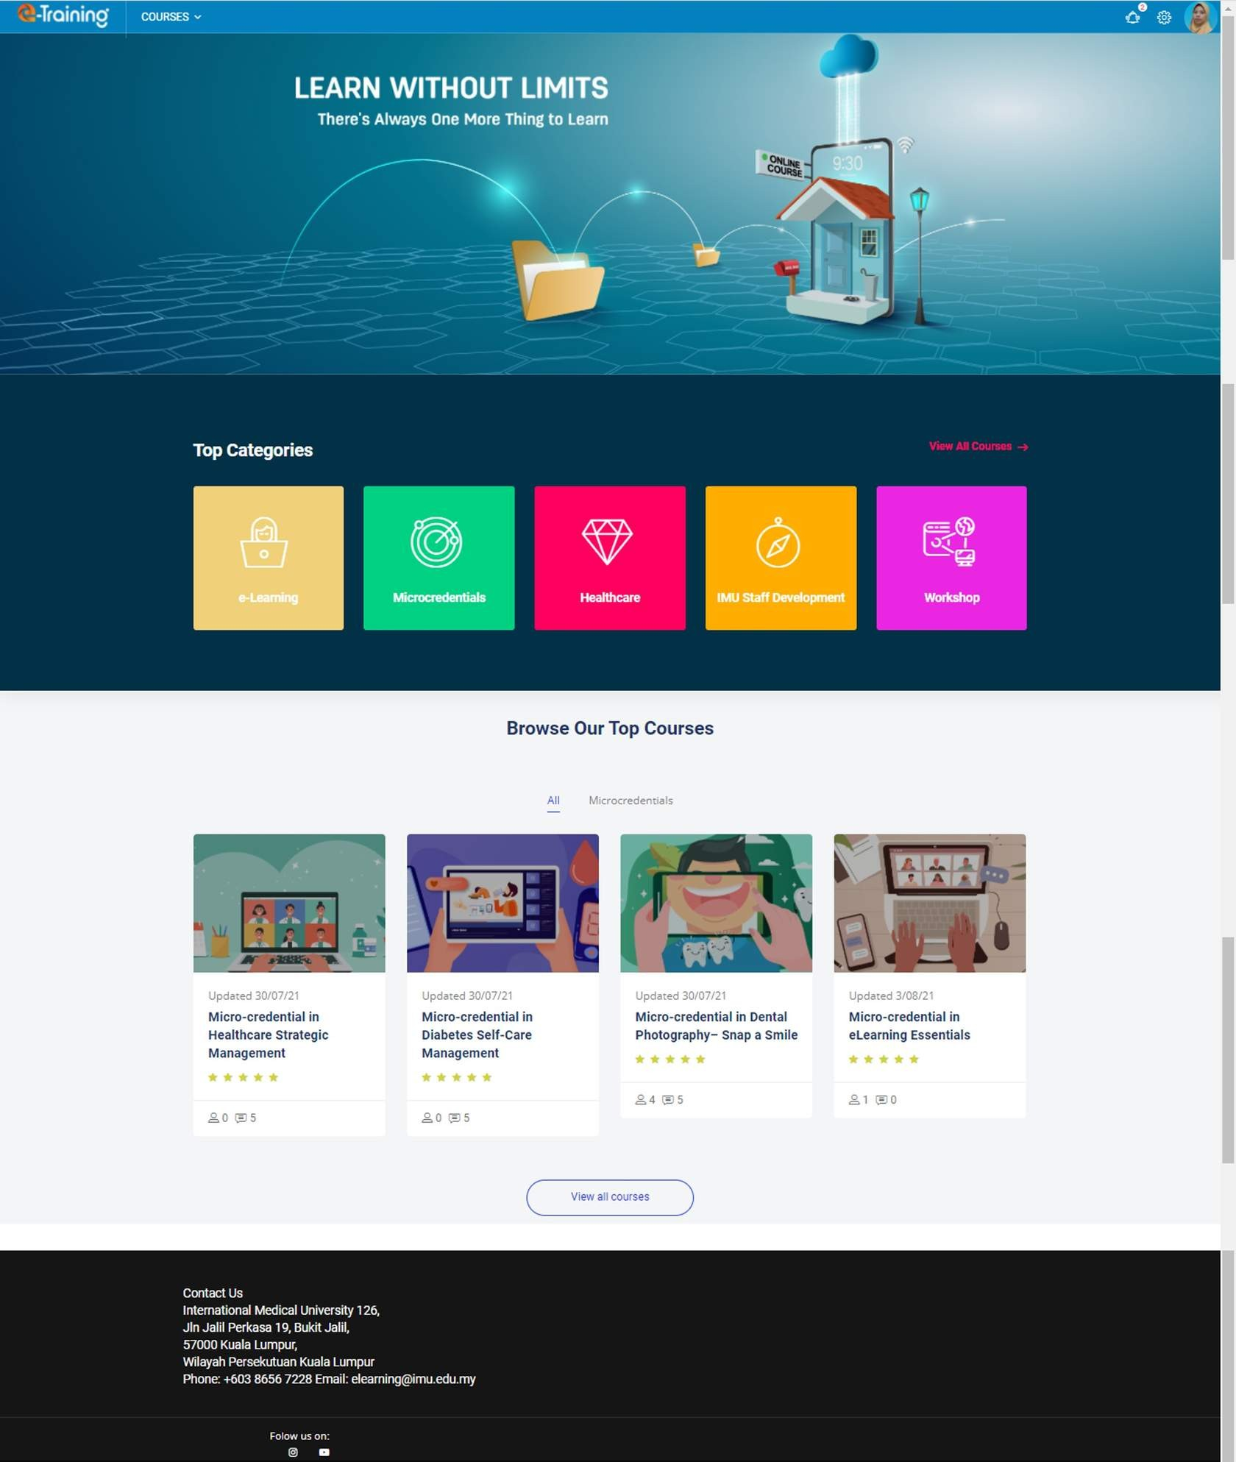
Course list
List of all courses available in the portal.
Top Categories
List of categories available in the portal.

Getting to Know your MiC Course Page

Course Page

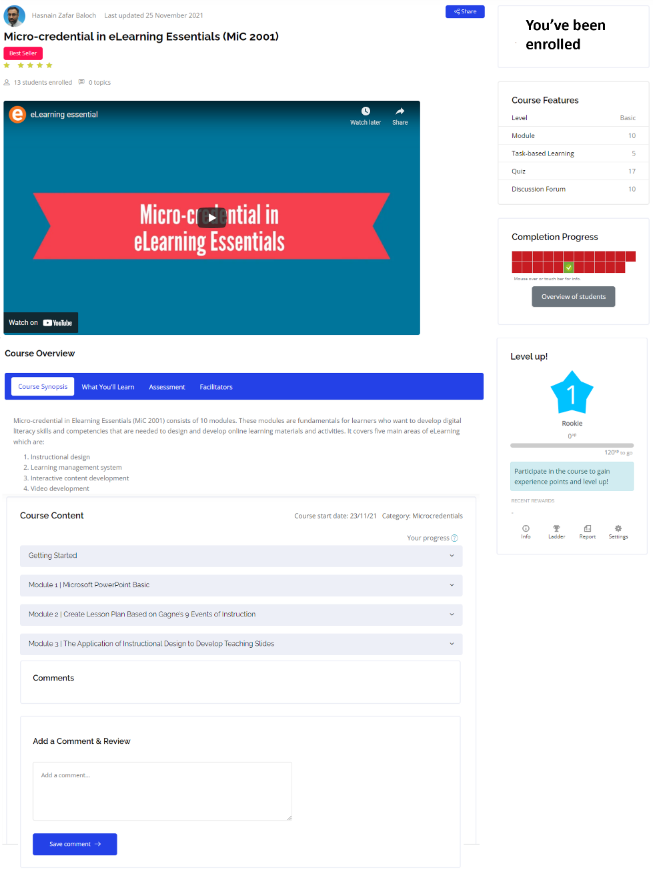
This is the main page of your Micro-credential course.
Introduction Video
An introduction video to introduce the course.
Course Overview
Detailed information of the course.
Course Content
You can click each module button to view the content.

Comment
You can add comment and review for this course.

Gamification Feature: Ladder board
You can view your rank and collected points here.
Completion Progress
An overall view of progress from all tracked activities. Red indicates incomplete activity, yellow indicates in progress activity, and green indicates completed activity. You can go to any tracked activity by clicking on each square.

Gamification Feature: Points
You can see your collected points based on completed activities.
Course Features
Provide details of the course.
Module Completion

To complete a module, you need to go through the learning material provided and complete all the activities.

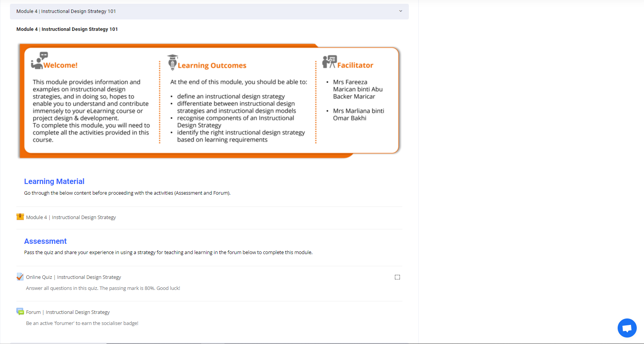

Getting Help Online

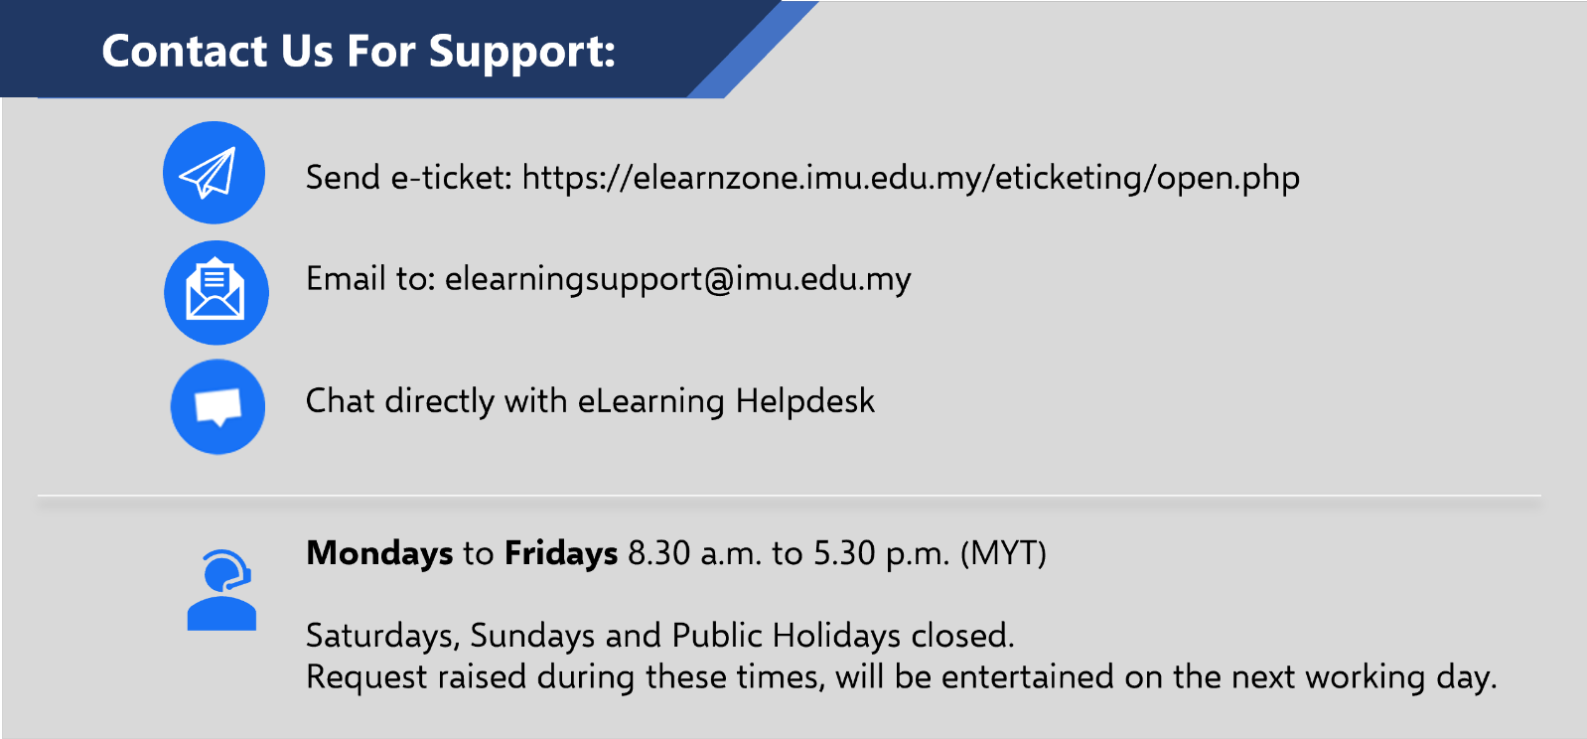
elearningsupport@imu.edu.my

https://elearnzone.imu.edu.my/eticketing/open.php

